Keyword Exercise

developed by Lou Rosenfeld sometime around 2002

There are two points to this exercise:
- Experience why SEO is challenging. Your goal is to create content that is optimized for the terms people are going to use to look for your product. However, internal perspectives get in the way.
- See for yourself that you are not your customer, and understand the need to learn about your customer and keep that information in your mind at all times.

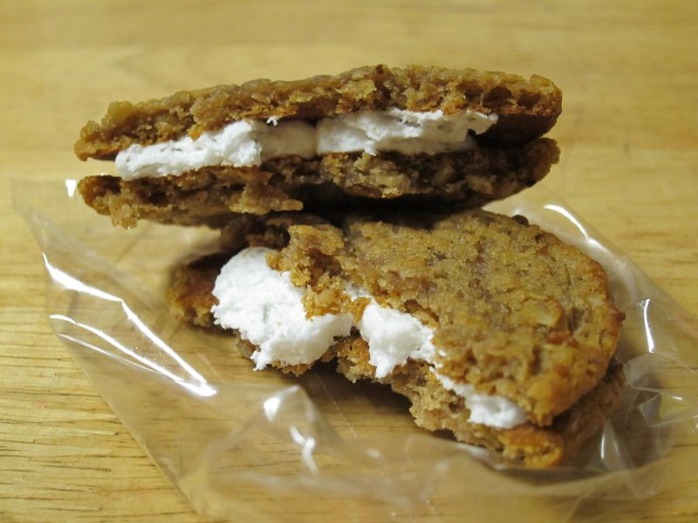
Supplies:

- Little Debbie Oatmeal Crème Pies*
(as many as you have participants)
- Paper lunch bags
- Large flip chart paper and markers (in a pinch, any paper and writing utensil will do)

Instructions:
The last page of this document is a set of three discussion prompts. Make copies of that page – 25% of the attendance at your event.

Cut the discussion prompts apart.

Into each lunch bag, put 3-5 pies and ONE discussion prompt.

Break up your group into smaller groups of 3-5 people, and hand each small group a bag. Don’t tell them the name of the object.

Give them about 5 minutes to do the exercise. (And yes, they are welcome to eat them when they’re done.)

Bring them back together and post the entries from each type of group together. (Some people will probably know what the item was.) Read all the entries aloud – start with the developer group, then the marketer group, and end with the consumers.

Typically, the “developers” choose terms that describe the object:
- round
- soft
- cream-filled
- dessert
- cookie
- chewy

The “marketers” identify clever phrases about what you can do with the product:
- a sweet treat you remember from your childhood
- healthy snack (ha ha!)
- skip-lunch treat
- the only cookie you’ll ever want
- scrumptious
- the dream-team of cookies
- so much more than a cookie
- scrumptious
- gooey
- afternoon delight
- plays well with coffee/tea

The “consumers” often know what they want
- oatmeal crème pie
- after-school snacks for kids
- cookie
- marshmallow
- gooey
- old-fashioned cookie
- dessert
- hostess

Now, discuss the similarities and differences between how each group described the identical object. (I’ve found that sometimes groups don’t do the exercise exactly as instructed, but that doesn’t really matter.)

* The reason these pies are what’s used in the exercise is that inside the box, the items are individually wrapped in clear cellophane with no identifying writing (still the case in 2014). If this ever changes, you’ll need to choose a different object for the exercise.

Discussion prompts: Cut the following page into three parts, each with one prompt. Put one slip into each bag.

You are a
DEVELOPER
who has just created this product.

Working as a team, please list 5-10 keywords and phrases that you would use to describe this product.

You are a
MARKETER
responsible for promoting this product.

Working as a team, please list 5-10 keywords and phrases you would use to promote this product.

You are a
CONSUMER
who wants this product.

Working as a team, please list 5-10 keywords and phrases you would use to look for this product.

